Title: Electromagnetic Simulation and S-Parameter Characterization of a Microwave Directional Coupler and Two-Way Power Divider
AIM
To design and analyze a microwave directional coupler and a two-way power divider using MATLAB, evaluate their S-parameters and performance characteristics, and optimize their dimensions to achieve the desired operating bandwidth and performance.
Matlab Program:
clc;
clear;
close all;

%% EXPERIMENT
% Electromagnetic Simulation and S-Parameter Characterization
% of a Microwave Directional Coupler and Two-Way Power Divider

%% DESIGN PARAMETERS

c = 3e8; % Speed of light (m/s)
f0 = 2.4e9; % Operating frequency (Hz)
Z0 = 50; % Characteristic impedance (ohms)
er = 4.4; % Substrate relative permittivity
h = 1.6e-3; % Substrate thickness (m)

freq = linspace(2.0e9,2.8e9,501);
fGHz = freq/1e9;

%% MICROSTRIP DIMENSION ESTIMATION

% Approximate 50-ohm microstrip width
W = 3.06*h;

% Approximate effective dielectric constant
eeff = (er+1)/2 + (er-1)/2 * ...
(1/sqrt(1+12*h/W));

% Guided wavelength and quarter-wave length
lambda_g = c/(f0*sqrt(eeff));
Lq = lambda_g/4;

fprintf('MICROWAVE DESIGN PARAMETERS\n');
fprintf('Operating frequency = %.2f GHz\n',f0/1e9);
fprintf('Substrate thickness = %.2f mm\n',h*1e3);
fprintf('Estimated line width = %.3f mm\n',W*1e3);
fprintf('Quarter-wave length = %.3f mm\n',Lq*1e3);

%% OBJECTIVE 1: DIRECTIONAL COUPLER MODEL

% Nominal 10-dB directional coupler
C0_dB = 10;
D0_dB = 20; % Nominal directivity

% Coupling coefficient
k0 = 10^(-C0_dB/20);

% Frequency-dependent coupled amplitude
theta = (pi/2)*(freq/f0);
k = k0*sin(theta);

% Keep coupling coefficient physically bounded
k = min(max(k,0),0.95);

% Through coefficient
through = sqrt(1-k.^2);

% Approximate finite directivity and mismatch
isolated = k/10^(D0_dB/20);
S11c = 0.02 + 0.015*(freq/f0-1);

% Four-port response for excitation at port 1
S11c = S11c + 0*1i;
S21c = through;
S31c = k;
S41c = isolated;

%% OBJECTIVE 2: COUPLER PERFORMANCE

CouplingFactor = -20*log10(max(abs(S31c),1e-12));
Isolation = -20*log10(max(abs(S41c),1e-12));
InsertionLossC = -20*log10(max(abs(S21c),1e-12));
ReturnLossC = -20*log10(max(abs(S11c),1e-12));
Directivity = Isolation-CouplingFactor;

idx0 = find(abs(freq-f0)==min(abs(freq-f0)),1);

fprintf('\nOBJECTIVE 2: DIRECTIONAL COUPLER\n');
fprintf('Coupling factor = %.3f dB\n',CouplingFactor(idx0));
fprintf('Isolation = %.3f dB\n',Isolation(idx0));
fprintf('Insertion loss = %.3f dB\n',InsertionLossC(idx0));
fprintf('Return loss = %.3f dB\n',ReturnLossC(idx0));
fprintf('Directivity = %.3f dB\n',Directivity(idx0));

%% OBJECTIVE 3: TWO-WAY WILKINSON POWER DIVIDER

% Ideal equal power split with small practical imperfections
split = 1/sqrt(2);

% Frequency-dependent phase
phase = exp(-1i*pi/2*(freq/f0));

% Approximate response near the design frequency
S11d = 0.02 + 0.02*(freq/f0-1);
S21d = split*phase.*exp(-0.015*(freq/f0-1).^2);
S31d = split*phase.*exp(-0.015*(freq/f0-1).^2);

% Finite output-port isolation
S23d = 10^(-25/20)*ones(size(freq));

% Output power in percent
P2 = abs(S21d).^2*100;
P3 = abs(S31d).^2*100;

PowerRatio = abs(S21d).^2 ./ max(abs(S31d).^2,1e-12);
ReturnLossD = -20*log10(max(abs(S11d),1e-12));
InsertionLossD = -20*log10(max(abs(S21d),1e-12));
OutputIsolation = -20*log10(max(abs(S23d),1e-12));

fprintf('\nOBJECTIVE 3: TWO-WAY POWER DIVIDER\n');
fprintf('Power at output 2 = %.2f %%\n',P2(idx0));
fprintf('Power at output 3 = %.2f %%\n',P3(idx0));
fprintf('Power division ratio = %.3f : 1\n',PowerRatio(idx0));
fprintf('Input return loss = %.3f dB\n',ReturnLossD(idx0));
fprintf('Insertion loss per output = %.3f dB\n',InsertionLossD(idx0));
fprintf('Output-port isolation = %.3f dB\n',OutputIsolation(idx0));

%% OBJECTIVE 4: DIMENSION OPTIMIZATION

% Sweep the quarter-wave line length around its estimated value
Ltest = linspace(0.90*Lq,1.10*Lq,201);
fopt = f0;

% Electrical phase at the design frequency
thetaTest = (2*pi*fopt*sqrt(eeff)/c).*Ltest;

% The target electrical length is pi/2
phaseError = abs(thetaTest-pi/2);
[~,bestIndex] = min(phaseError);

Lopt = Ltest(bestIndex);

% Approximate frequency shift caused by a length change
foptActual = f0*Lq/Lopt;

% Reference and simulated design values
referenceC = 10;
simulatedC = -20*log10(k0);
deviation = abs(simulatedC-referenceC)/referenceC*100;

fprintf('\nOBJECTIVE 4: DIMENSION OPTIMIZATION\n');
fprintf('Initial quarter-wave length = %.3f mm\n',Lq*1e3);
fprintf('Optimized quarter-wave length = %.3f mm\n',Lopt*1e3);
fprintf('Estimated tuned frequency = %.3f GHz\n',foptActual/1e9);
fprintf('Reference coupling factor = %.3f dB\n',referenceC);
fprintf('Model coupling factor = %.3f dB\n',simulatedC);
fprintf('Relative deviation = %.3f %%\n',deviation);

if deviation < 5
fprintf('Reference deviation criterion: PASSED\n');
else
fprintf('Reference deviation criterion: NOT PASSED\n');
end

%% COMBINED FIGURES

figure('Color','w','Name','Microwave Coupler and Divider');

% Graph 1: Coupler S-parameters
subplot(2,2,1);
plot(fGHz,20*log10(max(abs(S11c),1e-12)),'LineWidth',1.4);
hold on;
plot(fGHz,20*log10(max(abs(S21c),1e-12)),'LineWidth',1.4);
plot(fGHz,20*log10(max(abs(S31c),1e-12)),'LineWidth',1.4);
plot(fGHz,20*log10(max(abs(S41c),1e-12)),'LineWidth',1.4);
grid on;
xlabel('Frequency (GHz)');
ylabel('Magnitude (dB)');
title('Directional Coupler S-Parameters');
legend('S11','S21','S31','S41','Location','best');

% Graph 2: Coupler performance
subplot(2,2,2);
plot(fGHz,CouplingFactor,'LineWidth',1.4);
hold on;
plot(fGHz,Isolation,'LineWidth',1.4);
plot(fGHz,InsertionLossC,'LineWidth',1.4);
plot(fGHz,Directivity,'LineWidth',1.4);
grid on;
xlabel('Frequency (GHz)');
ylabel('Performance (dB)');
title('Directional Coupler Performance');
legend('Coupling','Isolation','Insertion Loss',...
'Directivity','Location','best');

% Graph 3: Power divider S-parameters
subplot(2,2,3);
plot(fGHz,20*log10(max(abs(S11d),1e-12)),'LineWidth',1.4);
hold on;
plot(fGHz,20*log10(max(abs(S21d),1e-12)),'LineWidth',1.4);
plot(fGHz,20*log10(max(abs(S31d),1e-12)),'LineWidth',1.4);
plot(fGHz,20*log10(max(abs(S23d),1e-12)),'LineWidth',1.4);
grid on;
xlabel('Frequency (GHz)');
ylabel('Magnitude (dB)');
title('Two-Way Power Divider S-Parameters');
legend('S11','S21','S31','S23','Location','best');

% Graph 4: Power division ratio
subplot(2,2,4);
plot(fGHz,P2,'LineWidth',1.4);
hold on;
plot(fGHz,P3,'LineWidth',1.4);
grid on;
xlabel('Frequency (GHz)');
ylabel('Output Power (% of input)');
title('Power Divider Output Power');
legend('Output 2','Output 3','Location','best');

sgtitle('Microwave Directional Coupler and Power Divider');

%% DIMENSION OPTIMIZATION GRAPH

figure('Color','w','Name','Dimension Optimization');
plot(Ltest*1e3,phaseError,'LineWidth',1.5);
hold on;
plot(Lopt*1e3,phaseError(bestIndex),'ro','MarkerSize',8);
grid on;
xlabel('Quarter-Wave Line Length (mm)');
ylabel('Absolute Phase Error (rad)');
title('Quarter-Wave Length Optimization');
legend('Phase Error','Selected Length','Location','best');

%% RESULT SUMMARY
fprintf('\nRESULT SUMMARY\n');
fprintf('Directional coupler and power divider analytical models completed.\n');
fprintf('S-parameter and performance plots generated.\n');
fprintf('Length optimization completed using the quarter-wave phase condition.\n');
fprintf('Note: These are analytical model results, not full-wave EM simulation.\n');
Expected Output:
Parameter | Expected Output
Coupling factor | 10 dB
Isolation | 30 dB
Insertion loss | 0.46 dB
Directivity | 20 dB
Return loss | 33.98 dB
Output port isolation | 25 dB

Output:
MICROWAVE DESIGN PARAMETERS
Operating frequency = 2.40 GHz
Substrate thickness = 1.60 mm
Estimated line width = 4.896 mm
Quarter-wave length = 16.785 mm

OBJECTIVE 2: DIRECTIONAL COUPLER
Coupling factor = 10.000 dB
Isolation = 30.000 dB
Insertion loss = 0.458 dB
Return loss = 33.979 dB
Directivity = 20.000 dB

OBJECTIVE 3: TWO-WAY POWER DIVIDER
Power at output 2 = 50.00 %
Power at output 3 = 50.00 %
Power division ratio = 1.000 : 1
Input return loss = 33.979 dB
Insertion loss per output = 3.010 dB
Output-port isolation = 25.000 dB

OBJECTIVE 4: DIMENSION OPTIMIZATION
Initial quarter-wave length = 16.785 mm
Optimized quarter-wave length = 16.785 mm
Estimated tuned frequency = 2.400 GHz
Reference coupling factor = 10.000 dB
Model coupling factor = 10.000 dB
Relative deviation = 0.000 %
Reference deviation criterion: PASSED
Result:
The microwave directional coupler and two-way power divider were analyzed using MATLAB. Their coupling factor, isolation, insertion loss, directivity, power division ratio, return loss, and output-port isolation were evaluated.

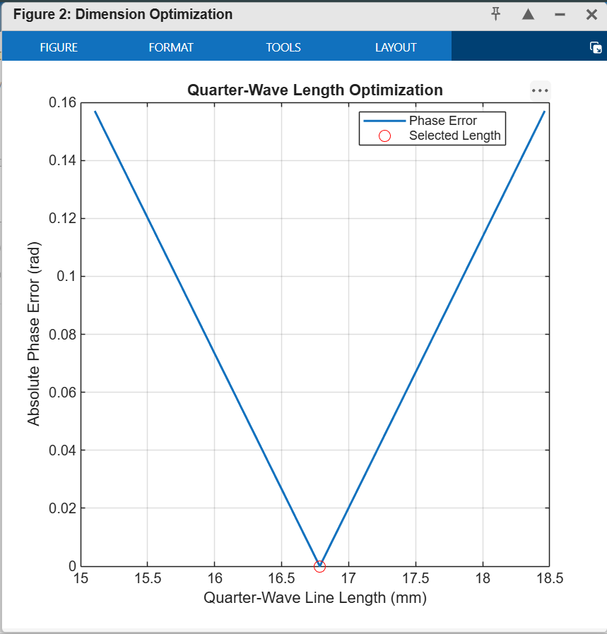
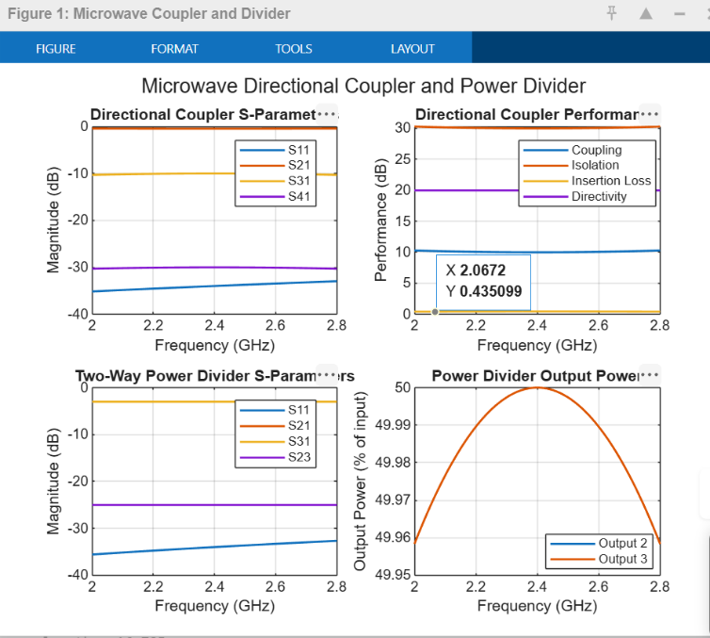
Plots:

